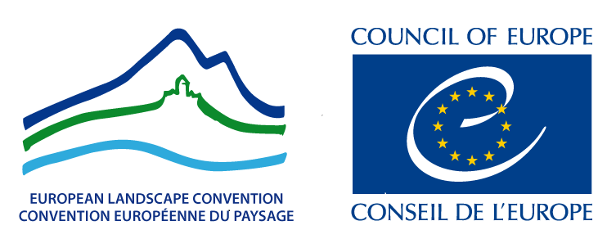

EUROPEAN LANDSCAPE CONVENTION

LANDSCAPE AWARD OF THE COUNCIL OF EUROPE

5th Session – 2016-2017

APPLICATION FORM

Presentation

The European Landscape Convention aims to promote the protection, management and planning of landscapes and to bring together European co-operation in this field. It is the first international treaty exclusively devoted to all dimensions of European landscape. Taking into account the landscape, natural and cultural values of the territory, it contributes to promoting the quality of life and well-being of Europeans.

The Resolution on the Rules governing the Landscape Award of the Council of Europe, adopted by the Committee of Ministers on 20 February 2008 at the 1018th meeting of the Ministers’ Deputies, draws attention to the fact that Article 11 of the Convention institutes the Landscape Award of the Council of Europe and that it is in keeping with the work carried out by the Council of Europe concerning human rights, democracy and sustainable development. It effectively promotes the territorial dimension of human rights and democracy by acknowledging the importance of measures taken to improve the landscape for people’s living conditions.

Opened to the Parties to the Convention, the Award is intended to raise civil society’s awareness of the value of landscapes, of their role and of changes to them. Its objective is to reward exemplary practical initiatives aimed at successful landscape quality objectives on the territories of the Parties to the Convention. The Award is conferred every two years and the files presenting applications must reach the Secretariat General of the Council of Europe.

At its meeting held in Strasbourg on 28-29 April 2008, the Steering Committee for Cultural Heritage and Landscape (CDPATEP) decided that applications should be submitted to the Council of Europe Secretariat through the Permanent Representations of the Parties to the Convention.

I would be very grateful if you could send no later than 30 January 2017 the following elements of the candidature file (10 pages maximum) established for your country on the basis of the proposals forwarded to you by the Ministries:

1) by E-mail, the Application form completed to: maguelonne.dejeant-pons@coe.int ;
2) by post, a copy of the Application form completed together with a CD-Rom or DVD containing the all the additional material to: Maguelonne Déjeant-Pons, Executive Secretary of the European Landscape Convention, Council of Europe, Agora (A3-32C), F- 67075 STRASBOURG Cedex.

* * *

– Participation to the Landscape Award of the Council of Europe is only open to local and regional authorities and their groupings and non-governmental organisations, as stated in the Resolution CM/Res (2008)3, Appendix, Article 2.
– The application form must be completed in all its parts, in one of the two official languages of the Council of Europe (English or French).
– The materials submitted must be copyright-free, for use by the Council of Europe in communications aimed at promoting the award or any other publications or activities relating to the Convention. The Council of Europe undertakes to cite the author’s names.
– Files that are incomplete or fail to comply with the rules will not be taken into consideration.

For further information please visit the Landscape Award section of the Council of Europe website: http://www.coe.int/EuropeanLandscapeConvention

* * *

I. STATE CONCERNED AND ApplicaNT

1. State

Represented by
Ms /Mr..

Ministry of ...

Address:

Tel.:

E-mail:

2. Applicant
Name of the local,
regional authority (ies)
or NGO(s)

Represented by
Ms /Mr..

Address:

Tel.:

E-mail:

II. PRESENTATION Of the Projet

3. Name of the Project

4. Location of
the Project

5. Summary of the Project (10 lines)

6. Photo representing the Project (high definition – JPEG 350 dpi) and name of the author of the photo please

III. CONTENT OF THE PROJECT

7. Start of the Project month year
The project must have been
completed three years previously

8. Partners

9. Financing bodies

10. Central aims of the Project

11. Outcome

IV. RESPECT OF THE CRITERIA OF THE ATTRIBUTION OF THE AWARD

12. Sustainable territorial development
Is the project part of a sustainable development policy?
Does it contribute to the enhancement of environmental, social, economic, cultural or aesthetic values of the landscape? How?
Has it successfully countered or posed a remedy to any pre-existing environmental damage or urban blight? How?

13. Exemplary value
Can the project be considered of exemplary value? Why?
Which are the good practices that it implemented?

- Public participation
Does the project actively encourage the public’s participation in the decision-making process? How?
Is the project in line with the wider policies implemented by national, regional or local authorities?

15. Awareness-raising
Is the project effectively increasing the public’s awareness of the importance of landscape in terms of human development, consolidation of European identity, or individual and collective well-being? How?

V. Additional material

Together with the printed version of the Application form, additional material in digital format should be included in one CD-Rom or DVD and returned by post or courier to:
Maguelonne Déjeant-Pons
Executive Secretary of the European Landscape Convention
Head of Division, Agora (A3-32C), Council of Europe
F-67075 STRASBOURG, Cedex
Tel: +33 (0) 3 88 41 23 98
E-mail: maguelonne.dejeant-pons@coe.int

- Text (10 pages max.): PDF format
- Photos (10 max.): JPEG 350 dpi high definition
- Posters (2 max.): PDF format high definition or JPEG 350 dpi high definition
- Video (15mn max.): mpeg 2 format - It is advised to present a video (even of amateur quality).

* * *

